OCEANSIDE PLACE – RESTART GUIDELINES

It is very important that all persons follow the guidelines of the Oceanside Place Restart Plan and the Return to Sport Plan provided by the sports organizations that are relevant to their activities. These guidelines have been established to ensure the safety, health and well being of the public and staff and to minimize exposure to the coronavirus. We appreciate everyone’s support as we proceed to a restart of Oceanside Place and the opportunity for participating in recreation with the objective of staying active and healthy!

ARRIVAL/EXIT

* Participants may arrive no sooner than 20 minutes prior to their session and must exit the facility no later than 20 minutes after their session.
* Drop off and pickup will be at the front of the building and entry shall be through the designated entrance which is the automatic doors to the lobby.
* No access will be available through the rear lobby entrance.
* Each group will have a designated person acting as an “Ambassador” at the front door to supervise the group and ensure that unauthorized individuals do not enter the facility.
* Visitors to the facility will not be permitted to enter based on the following criteria:

1. if they are displaying symptoms of illness,
2. have had close contact with someone with respiratory illness or a confirmed or probable case of COVID-19;
3. have travelled outside of Canada or have been in close contact with someone who has travelled outside of Canada within the past 14 days.

* One parent /adult per skater is permitted to come to the arena with the participant if the group’s Return to Sport plan and the facility allows (no siblings or other children).
* Floor markings and arrows for directional flow have been marked as follows:

- ENTRY/ACCESS - EXIT  - Median 

SAFETY/HYGIENE PROTOCOLS

* Please practice physical distancing of 2m while at the facility.

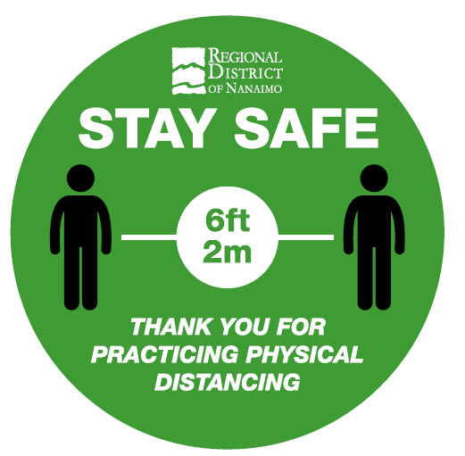 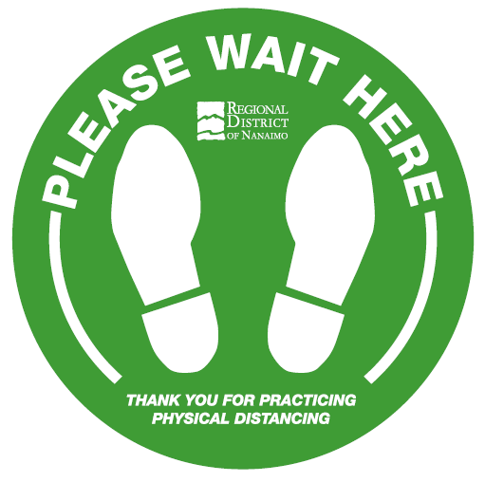

* No spitting is allowed in the facility or on ice.
* Do not share water bottles, towels or equipment.
* Please use hand sanitizer or wash your hands upon entering and after any of the following activities:

1. using the washroom,
2. sneezing or blowing their nose,
3. touching the face,
4. cleaning, sweeping, mopping,
5. eating, drinking,
6. entering and leaving the facility and prior to and after meal/rest breaks.

* The frequency of cleaning and sanitizing has been increased in all public spaces with an emphasis on frequent or high touch points of contact areas.

LOBBY

* Washrooms are available but only 1 person allowed at a time.
* Benches have designated spaces for seating to maintain physical distancing.
* Maximum occupancy is 24 persons.
* Public lockers and water fountains will not be available for use until further notice. The bottle fill station will be available.
* An isolation room, situated adjacent to the skate shop window, has been designated for use when an employee or patron becomes ill or displays symptoms of illness during their shift or activity at Oceanside Place and are unable to leave the facility immediately. No other use of this room shall occur until further notice.

FIRST AID PROTOCOL

* The WorkSafe BC First Aid protocol provides guidelines for those that provide first aid assistance to employees and the public.
* Groups are responsible for first aid for their participants and spectators.

HOWIE MEEKER ARENA

* Ice will be available for August 3, 2020 for limited use.
* Maximum occupancy is 24 persons, which includes players, coaches, instructors.
* Spectator seating may be available and when allowed seating is designated to maintain physical distancing of 2m.
* Activities shall follow the guidelines of the Return to Sport Plan.

VICTOR KRAATZ ARENA

* The floor will be a dry floor until further notice and is available for bookings.
* Maximum occupancy is 24 persons.
* No spectator seating is available until further notice.

DRESSING ROOMS

* Dressing room occupancy level is designated as 6 persons.
* The group is responsible for supervision of the rooms, corridors, and ice/floor activities.
* Showers will not be available until further notice.
* Rooms will be made available 20 minutes prior to the session and users shall exit no later than 20 minutes after the session.
* Hand sanitizer is available in the corridors and soap dispensers are available at the sinks in the rooms.

OCEANSIDE POND

* This will be a dry floor and will not be available for public booking until further notice.
* RDN programs/camps will be using this venue.

MEETING ROOMS

* The multi purpose room is available for bookings and maximum occupancy is 20 persons.
* The public meeting room in the upper foyer will not be available until further notice.

BOOKINGS/PERMITS

* Requests for bookings shall be via phone or e-mail to the Arena Program Secretary

at 250-248-3252 or [dcouturier@rdn.bc.ca](mailto:dcouturier@rdn.bc.ca).

* Full details will be required when booking including the type of activity, age group involved, number of participants.
* Sports organizations and groups will need to submit a Return to Sport Plan providing guidelines for maintaining the directives from the Province, PHO, Via Sport BC and /or their sports governing association. <https://www.viasport.ca/return-sport>
* Upon completion of reviewing the requests, permits will be drafted and sent to you for review and signing.
* Please take the time to review the permit carefully in order to ensure that details are accurate and as requested and that you understand the Disclaimer.
* If adjustments are required, please advise our office immediately so that we can finalize bookings in a timely manner.
* Once the permit information is found satisfactory, then the User shall sign and date the permit, the COVID-19 Addendum and include a copy of the Users General Commercial Liability Insurance naming the Regional District of Nanaimo (RDN) as an additional insured and forward the documents to our office. The contract will be then signed by the Superintendent of Arenas Services or designate which will effectively confirm the contract between the RDN and the Renter.